CSC224



**e. Four Major Problems Handled by the OS Memory Manager:**

**1. Allocation and Deallocation:**

- The memory manager is responsible for allocating memory space to processes as needed and deallocating it when processes finish. It must efficiently manage available memory to avoid wastage.

**2. Memory Protection:**

- Ensures that processes do not interfere with each other's memory space. The memory manager enforces access control, preventing unauthorized access to specific memory regions and safeguarding the integrity of running processes.

**3. Address Binding:**

- Involves mapping logical addresses used by a program to physical addresses in the computer's memory. The memory manager handles tasks like compile-time, load-time, and runtime address binding to ensure correct execution of processes.

**4. Memory Sharing:**

- Facilitates sharing of memory space among multiple processes to improve efficiency. This involves implementing mechanisms like shared memory or memory-mapped files, allowing processes to communicate and collaborate.

**f. Differentiation between Internal and External Fragmentation:**

**- Internal Fragmentation:**

- Definition: Occurs when allocated memory is larger than necessary, leading to wasted space within a memory block.

- Cause: Typically results from fixed-size memory allocation, causing smaller processes to occupy larger memory blocks.

- Impact: Reduces overall efficiency as portions of memory remain unused due to the size disparity between allocated blocks and actual process requirements.

**- External Fragmentation:**

- Definition: Arises when free memory blocks are scattered throughout the system, making it challenging to allocate contiguous space for larger processes.

- Cause: Frequent allocation and deallocation of variable-sized memory blocks create gaps between allocated regions, making it difficult to find suitable contiguous space for incoming processes.

- Impact: Diminishes the available usable memory, even if the total free memory is sufficient. Memory compaction or relocation may be needed to address external fragmentation.

Hi! Here are four valid reasons for process suspension by the operating system:

1. **I/O Operations**: When a process initiates an input/output operation, such as reading from disk or writing to a file, it may be suspended while waiting for the operation to complete.  
   2. **Resource Allocation**: If a process requests a scarce system resource, such as memory or CPU time, and the resource is not immediately available, the process may be suspended until the resource becomes available.  
   3. **Waiting for Event**: Processes may be suspended while waiting for certain events to occur, such as signals from other processes or hardware interrupts.  
   4. **Priority Adjustment:** In a multitasking environment, if a higher-priority process becomes ready to run, the operating system may suspend a lower-priority process to allocate resources to the higher-priority one.  
   

Mutual exclusion is a concept in operating systems that ensures only one process at a time can access a shared resource or a critical section of code. It prevents multiple processes from simultaneously modifying a shared resource, avoiding conflicts and maintaining data integrity.

Importance in operating systems:  
1**. Data Integrity**: Mutual exclusion prevents data corruption that could occur if multiple processes simultaneously read and write to shared resources. It ensures that modifications are carried out in a controlled and orderly manner.

**2. Consistency**: By allowing only one process to access a critical section at a time, mutual exclusion ensures that the system progresses in a consistent state. This is crucial for maintaining the correctness of operations and avoiding unexpected outcomes.

3. **Concurrency Control**: Mutual exclusion is essential for managing concurrent access to shared resources in a multi-process or multi-threaded environment. It helps prevent race conditions and other concurrency-related issues.  
In summary, mutual exclusion is vital for maintaining the integrity, consistency, and controlled access to shared resources in an operating system, ensuring that concurrent processes do not interfere with each other in a way that leads to errors or data corruption.

Sure, here are the four necessary requirements for mutual exclusion in the depicted traffic deadlock scenario:

**1. Exclusive Access**: Each vehicle must have exclusive access to the section of the road it occupies. This means that once a vehicle enters a section of the road, no other vehicle can enter that same section until the first vehicle exits.  
**2. Hold and Wait**: Vehicles must be allowed to hold onto the resources (sections of the road) they already possess while requesting additional resources. This ensures that deadlock situations, where each vehicle is waiting for a resource held by another vehicle, are possible.

**3. No Preemption**: The operating system cannot forcibly take control of a section of the road from a vehicle. Once a vehicle occupies a section of the road, it must voluntarily release it.

**4. Circular Wait**: There must exist a circular chain of two or more vehicles, each holding a resource that is requested by the next vehicle in the chain. This circular wait condition is essential for deadlock to occur in this scenario.

**ii. State a simple rule that will avoid deadlocks in this system. [2 Marks]**

A simple rule to avoid deadlocks in this system is to ensure that vehicles always request resources (sections of the road) in the same order. This means that if a vehicle is holding a resource (section of the road) and needs another resource to proceed, it should only request the next resource in the sequence. This prevents circular wait conditions, which are necessary for deadlocks to occur.

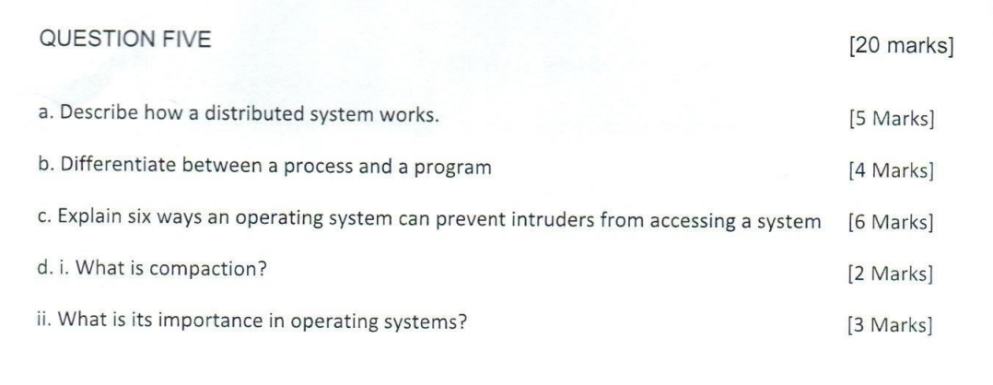a. How a Distributed System Works:

A distributed system is a network of interconnected computers that work together to achieve a common goal. It operates by dividing tasks among multiple computers, allowing them to collaborate on processing, storage, and communication. Key aspects include:

1. Communication: Computers in a distributed system communicate with each other through a network. This communication facilitates the sharing of data and coordination of tasks.

2. Resource Sharing: Resources such as files, processing power, and storage are shared among the computers in the system. This enhances efficiency and scalability.

3.Concurrency: Multiple tasks can be executed concurrently on different machines, leading to improved performance and faster task completion.

4. Fault Tolerance: Distributed systems often incorporate redundancy and fault tolerance mechanisms, ensuring continued operation even if some components fail.

5. Transparency: Distributed systems aim to provide transparency to users, meaning they interact with the system as if it were a single, unified entity.

b. Difference between Process and Program:

- Program: A program is a set of instructions written in a programming language. It is a passive entity, stored on a disk, and becomes active when loaded into memory for execution.

- Process: A process is an active entity, an instance of a program in execution. It includes the program code, current activity, and a unique process identifier.

c. Ways an Operating System Can Prevent Intruders:

1. Authentication: Require valid credentials (username and password) for access.

2. Authorization: Control access privileges based on user roles and permissions.

3. Encryption: Secure data by converting it into a coded format, preventing unauthorized access.

4. Firewalls: Implement network firewalls to filter incoming and outgoing traffic, blocking potential intruders.

5. Intrusion Detection Systems (IDS):Monitor system activities for suspicious behavior and raise alarms.

6. Regular Updates and Patching: Keep the operating system and software up-to-date to fix security vulnerabilities.

d. i. Compaction:

Compaction is the process of rearranging memory segments to eliminate or reduce fragmentation. It involves moving processes to consolidate free memory into a large contiguous block.

ii. Importance in Operating Systems:

- Memory Utilization: Compaction reduces fragmentation, allowing the efficient utilization of memory by allocating larger contiguous blocks to processes.

- Prevention of Fragmentation: By compacting memory, it helps prevent fragmentation issues, both external and internal, ensuring smoother and more efficient memory management.

- Improved Performance: Reduced fragmentation leads to faster memory access times, contributing to improved overall system performance.